VAHA 2107:
PAINTING 1

VISUAL EDUCATION

Plan:
- Definition of colors
- Importance of light
- Study of colors Theory
- Colors symbolism
- The Water color technique
Understanding the meaning of Visual Education
Visual literacy in education develops a student's visual literacy, their ability to comprehend, make meaning of, and communicate through visual means, usually in the form of images or multimedia.
- DEFINITION OF COLOURS
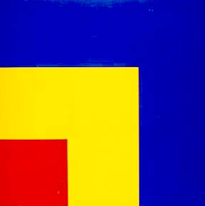
Color is the property possessed by an object of producing different sensations on the eye as a result of the way it reflects or emits light. It’s the visual response to different wavelengths of sunlight identified as red, green, blue and so on, having the physical properties of hue, intensify and value.
There are three properties to color:
- First is hue, which simply means the name we give to a color (red, yellow, blue, etc.).
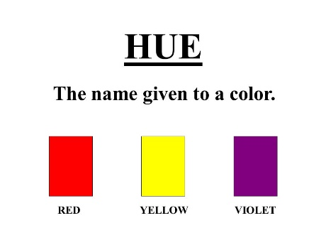
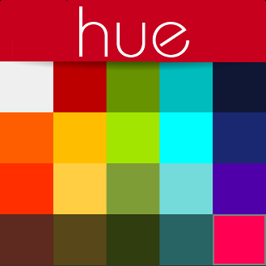

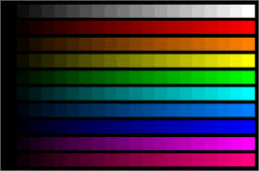
- The second property is intensity, which refers to the strength and vividness of the color. For example, we may describe the color blue as "royal" (bright, rich, vibrant) or "dull" (grayed).
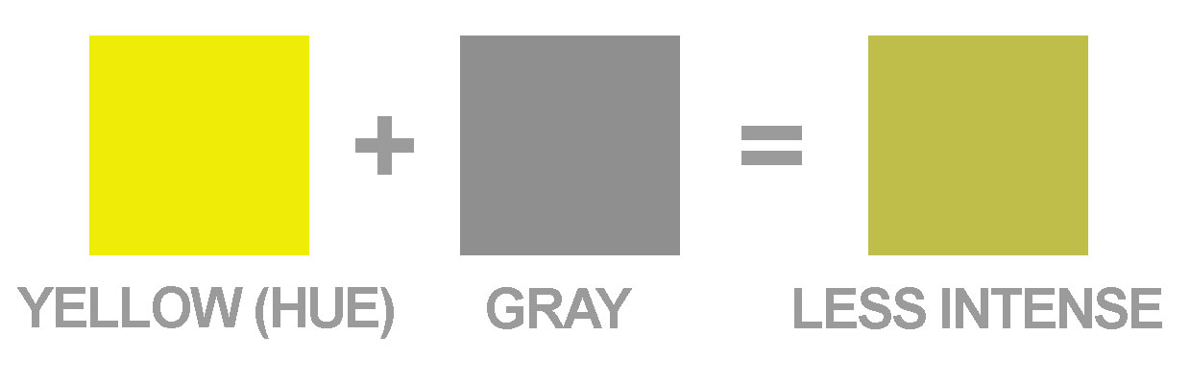

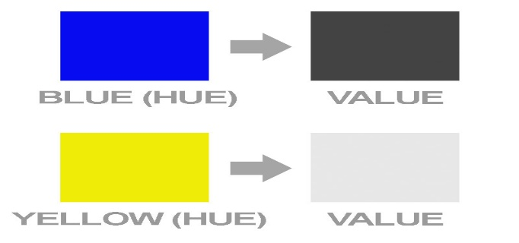
- The third and final property of color is its value, meaning its lightness or darkness.

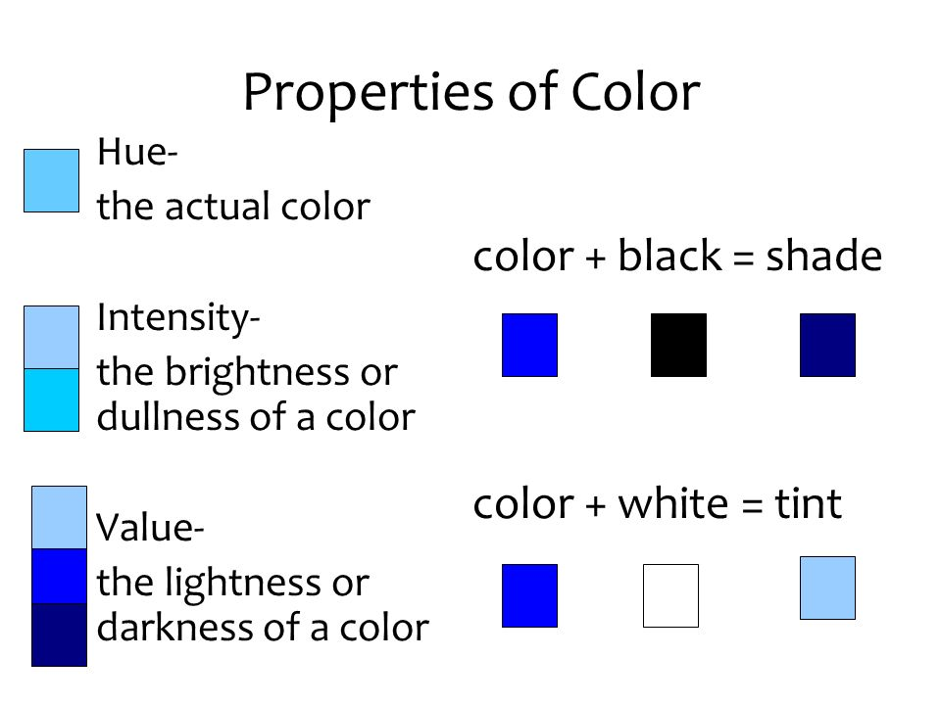

Color is one of the most expressive element because it affects our emotions directly. When we view a work of art, we don’t have to rationalyse what we are supposed to feel about it’s color; instead, we have an immediate emotional reaction to it. Pleasing rhythms and harmonies of colors satisfy our aesthetic desires. We like certain combinations of color and reject others.
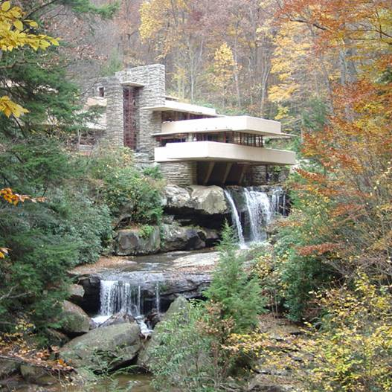

Color has an affect over how we feel about objects, how we behave, and how our bodies react to circumstances.
In representational art, color identifies objects and creates illusionistic space. The study of color is based on scientific theory, principles that can be observed and easily systematized.

2. IMPORTANCE OF LIGHT
Light is the brightness that lets you see things. It’s something that makes things visible or affords illumination All (colors depend on light). Light is electromagnetic radiation within a certain portion of the electromagnetic spectrum. The word usually refers to visible light, which is visible to the human eye and is responsible for the sense of sight. Often describes the light source or light reflected within the composition. In realistic compositions, if there is light, there is colors.
The light is the source of color.
Colors begins with and is derived from light, either natural or artificial. Where there is little light is strong, color is likely to be intense. When the light is weak, such as at dusk or dawn, it is difficult to distinguish one color from another. Under bright, strong sunlight, as i tropical climates, colors seem to take on additional intensity.
Every ray of light coming from the sun is composed of waves that vibrate at different speeds. The sensation of colors is aroused in the mind by the way our sense of vision responds to the different wavelengths. This can be demonstrate by observing the way a beam of white light passes through a triangle-shaped piece of glass a (a prism) and then reflects off a sheet of white paper. The rays of light bend, or refract, as they pass through the glass at different angles and then reflect off the white paper as different colors.
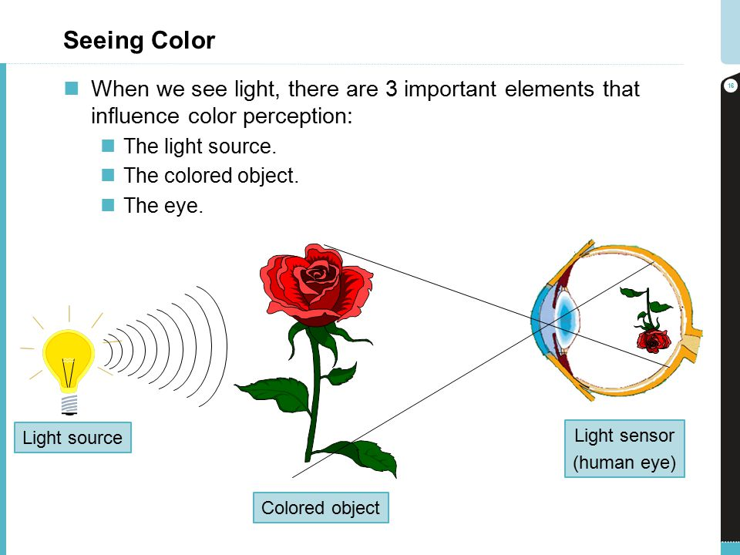


The human eye has specialized cells that are sensitive to different ranges of colors. These specialized cells are called cones. There are three types of cones, each sensitive to different ranges of color: red, green, and blue. When light hits the cones, the cones send messages to your brain. The color that you see depends on the type and number of cones responding to the light entering your

– The white light from the sun reaches the object.
– All the colors are absorbed, except the red.
– The red is the color that we see
Some people can not see all the colors; some people are color- blind. Their cone cells may be defective, causing them to be yellow and green color blind or red and green colored blind.

3. COLOR THEORY
Color theory is both the science and art of color. It explains how humans perceive color; how colors mix, match or clash; the subliminal and often cultural messages colors communicate; and the methods used to replicate color.
In the visual arts, color theory is a body of practical guidance to color mixing and the visual effects of a specific color combination. There are also definitions (or categories) of colors based on the color wheel: primary color, secondary color and tertiary color
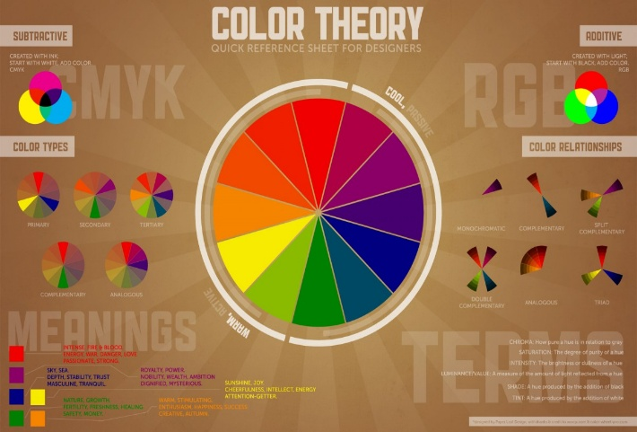

The color wheel is the first model use to illustrate the relationship between different colors.
The color wheel consists of three primary colors (red, yellow, blue), three secondary colors (colors created when primary colors are mixed: green, orange, purple) and six tertiary colors(colors made from primary and secondary colors, such as blue-green or red-violet).
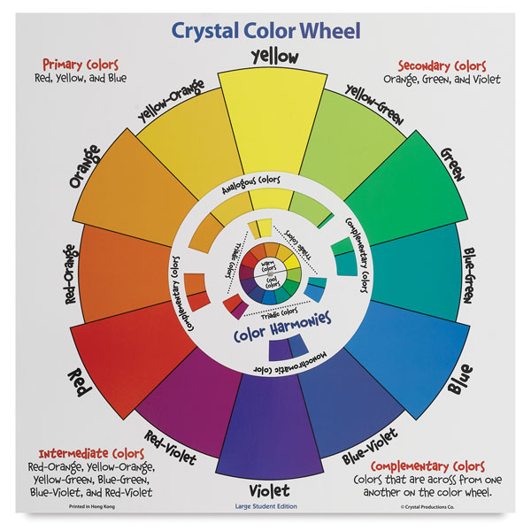

- Primary colors
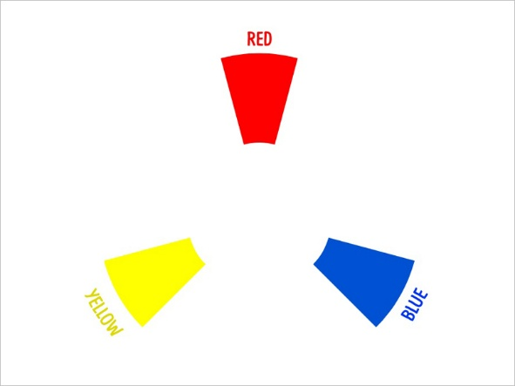
The most basic of colors are primary colors, which are red, blue and yellow. They cannot be made from mixing any two colors and, as their name implies, they are the basis of all other colors.

- Secondary colors
The secondary colors are derived from combinations of the primary colors. They are violet, orange and green.
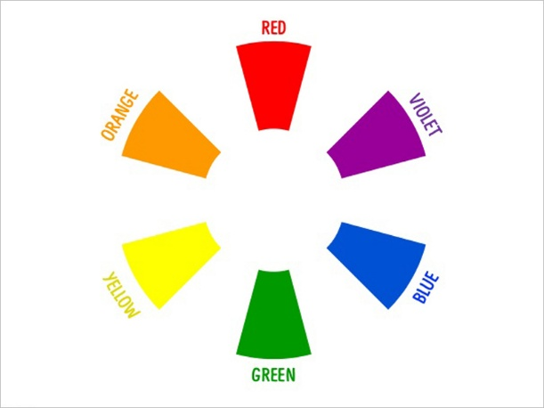

- Tertiary colors
Lastly, the tertiary colors are created when you combine a primary color with a secondary color, resulting in one of the six following colors: red-orange, red-violet, blue-violet, blue-green, yellow-green and yellow-orange.
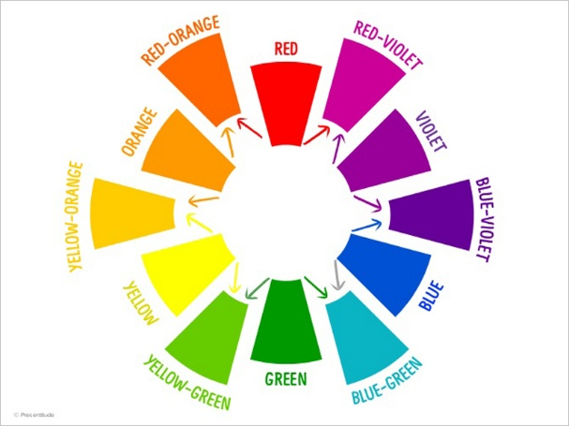

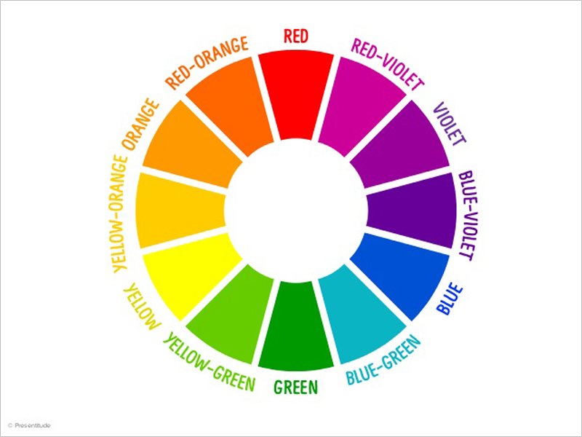
These 12 colors compose the complete color wheel:

NB: At this point, you might be asking yourself, “Why aren’t black and white on the color wheel?” The uncomplicated answer is that black is the absence of color, while white is the combination of all colors.
If you draw a line through the center of the wheel, you’ll separate the warm colors (reds, oranges, yellows) from cool colors (blues, greens, purples).
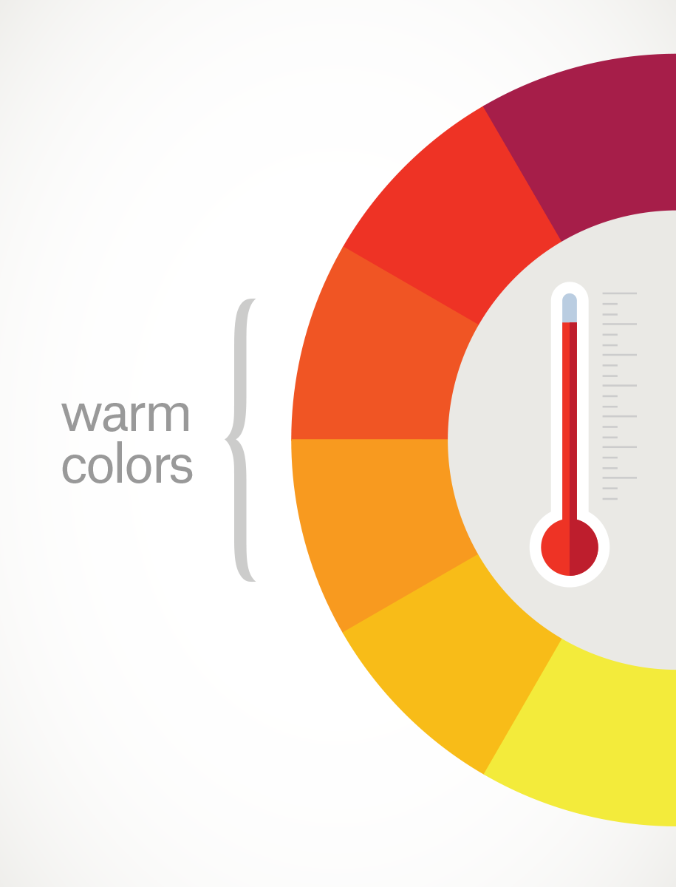
Warm colors are generally associated with energy, brightness, and action, whereas cool colors are often identified with calm, peace, and serenity.
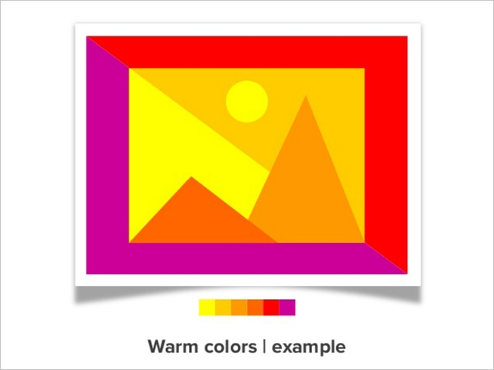
.

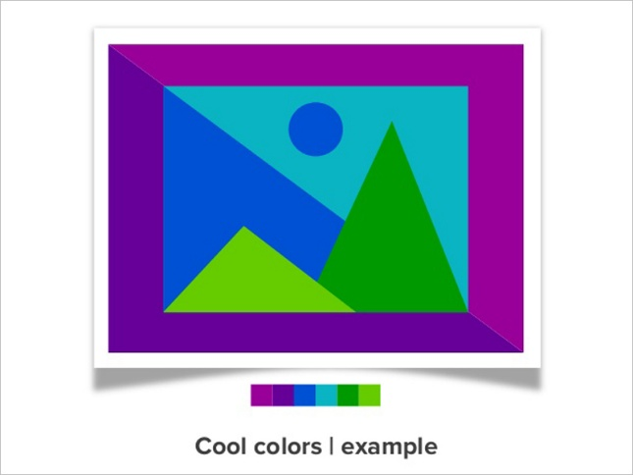
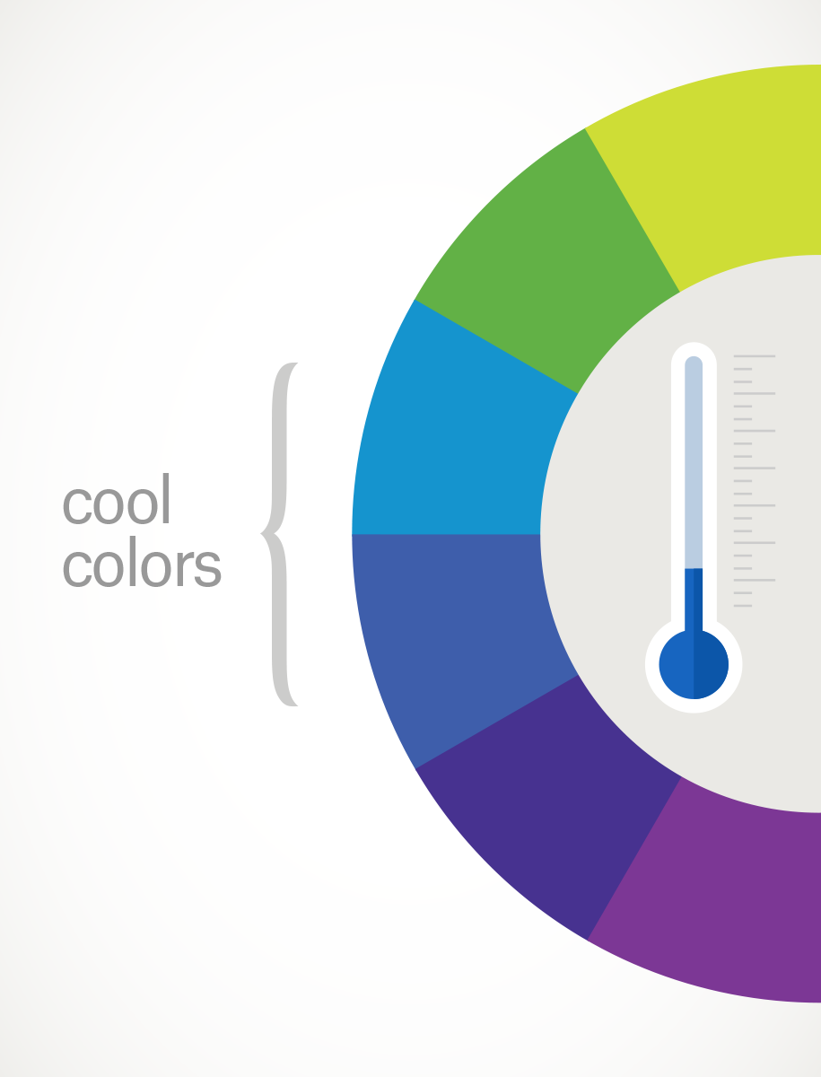

- Complementary colors
Complementary colors are pairs of colors which, when combined, cancel each other out. They are two colors that are on opposite sides of the color wheel.
A pair of complementary colors is made up of one cool color and one warm color. Orange, reds, and yellows are our warm colors while blues, greens, and purples are our cool colors. This helps create what is known as simultaneous contrast, the highest contrasts available on the color wheel.
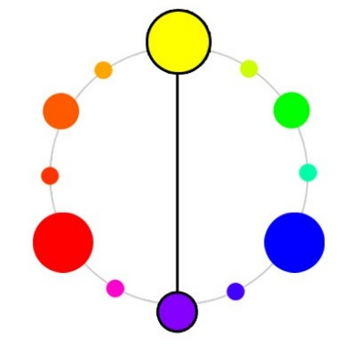
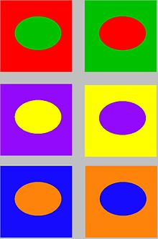

- Hue, tint, tone and shade
It is important to differentiate between Hue, tints, tones and shades.
- When a color is mixed with white, you create tints. These are lighter than the pure hue:
- When a color is mixed with grey, you create tones, which are duller than the pure hue:
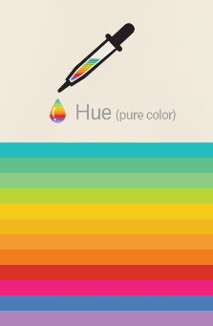
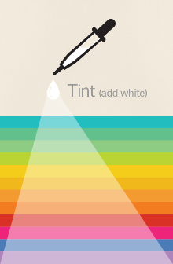
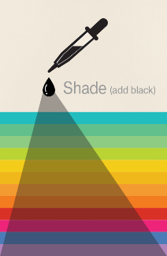
- When a color is combined with black, you have shades. These are darker than the original hue:
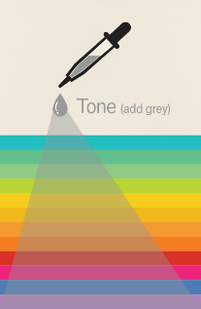

- Hue is the name given to a color
- A tint is a hue to which white has been added. For example, red + white = pink.
- A shade is a hue to which black has been added. For example, red + black =
- A tone is a color to which black and white (or grey) have been added.

- Additive And Subtractive Color
The additive model is based on mixing the light (The more light you add, the brighter the color mix becomes) while,
The subtractive model is based on mixing the pigments (subtract the light from the paper by adding more color.)
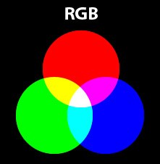
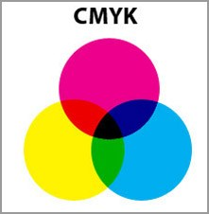

- COLOR SYMBOLISM
Color symbolism in art and anthropology refers to the use of color as a symbol in various cultures. There is great diversity in the use of colors and their associations between cultures and even within the same culture in different time periods. The same color may have very different associations within the same culture at any time. For example, red is often used for stop signs or danger. At the same time, red is also frequently used in association with romance, e.g. with Valentine’s Day. White variously signifies purity, innocence, wisdom or death. Blue has similarly diverse meanings.
Colors play a very important role in our lives, whether we realize it or not. They have the ability to affect our emotions and moods in a way that few other things can.
Diversity in color symbolism occurs because color meanings and symbolism occur on an individual, cultural and universal basis. Color symbolism is also context-dependent and influenced by changes over time.

- A PREVIEW OF EACH COLORS MEANING
- THE COLOR YELLOW
Joy, optimism, happiness, danger, sunshine, idealism, imagination, hope, summer, gold, deceit, philosophy, dishonesty, cowardice, betrayal, jealousy, disease and warning.
- THE COLOR RED
Excitement, energy, passion, love, desire, speed, strength, power, heat, aggression, danger, fire, blood, war, violence, all things intense and passionate, sincerity, happiness.
- THE COLOR BLUE
Peace, tranquility, cold, water, calm, stability, harmony, unity, trust, truth, confidence, conservatism, security, cleanliness, order, loyalty, sky, water, technology, stability, masculinity and protection.
- THE COLOR GREEN
Nature, environment, health, good luck, renewal, youth, vigor, spring, generosity, fertility, jealousy, inexperience, envy, misfortune, start signal, St. Patrick’s Day and Christmas.
- THE COLOR ORANGE
Energy, balance, warmth, enthusiasm, vitality, expansion, flamboyant, autumn and Halloween, vibrant, demanding of attention.
- THE COLOR PURPLE
Royality, nobility, spirituality, ceremony, mystery, transformation, wisdom and enlightenment, cruelty, honor, arrogance, mourning, temperance.
- THE COLOR PINK
Love and romance, caring, tenderness, acceptance and calm.
- THE COLOR BROWN
Earth, stability, hearth, home, outdoors, reliability, comfort, endurance, simplicity, and comfort.
- THE COLOR GRAY
Security, reliability, intelligence, staid, modesty, dignity, maturity, solid, conservative, practical, old age, sadness, boring. Silver symbolizes calm.
- THE WHITE
Reverence, purity, virginity, birth, simplicity, cleanliness, peace, humility, precision, innocence, youth, winter, snow, good, sterility, marriage (Western cultures), death (Eastern cultures), cold, clinical.
- THE BLACK
Power, sophistication, formality, elegance, wealth, mystery, fear, evil, anonymity, unhappiness, depth, style, sad, remorse, anger, mourning, underground, technical, grief and death.

